**Laboratory 23**: Intro to Logic Design

(Edit this document as needed)

Partner 1: John Gonzalez

Partner 2:Saaif Ahmed

*Part A Binary Numbers*

Brief description of the Binary numbers:

Binary numbers are not decimal. In fact they are base 2 numbers. They represent a lot of information in simple circuits and can be scaled up very easily. Since circuits are either ON or OFF, the values of 1 and 0 in binary can represent a form of logic.

Determine the equivalent binary number for the indicated the decimal number.

|  |  |
| --- | --- |
| Decimal Number | Binary Number |
| 13 | 1101 |
| 3300 | 1100 1110 0100 |

Complete the binary number conversion chart for decimal numbers 0-15.

|  |  |
| --- | --- |
| Decimal Number | Binary Number |
| 0 | 0 |
| 1 | 1 |
| 2 | 10 |
| 3 | 11 |
| 4 | 100 |
| 5 | 101 |
| 6 | 110 |
| 7 | 111 |
| 8 | 1000 |
| 9 | 1001 |
| 10 | 1010 |
| 11 | 1011 |
| 12 | 1100 |
| 13 | 1101 |
| 14 | 1110 |
| 15 | 1111 |

*Part B Logic Gates*

Brief description of the logic gates analysis:

The objective of this experiment is to analyze the characteristics of logic gates and what the output will be depending on the input. Also to determine the different ways the logic gates can be noted.

Identify the following gates and fill in the Truth Table for each gate.



|  |  |  |
| --- | --- | --- |
| NOT Gate- 1, 0 | NOR Gate- 1, 0, 0, 0 | (NOT then AND)1, 0, 0, 0 |
| NOT XOR Gate- 1, 0, 0, 1 | NAND Gate- 1, 0, 0, 0 | OR Gate- 0, 1, 1, 1 |
| XOR- 0,1,1,0 | AND Gate- 0, 0, 0, 1 | (NOT then OR)1, 1, 1, 0 |

Screen capture of Logic-Lab examples with one input set high and one input set low. On the previous question, indicate the corresponding line in the truth table.



This is a NOT gate, When IN = 0, OUT = 1

Redraw the following gate in its more common form.



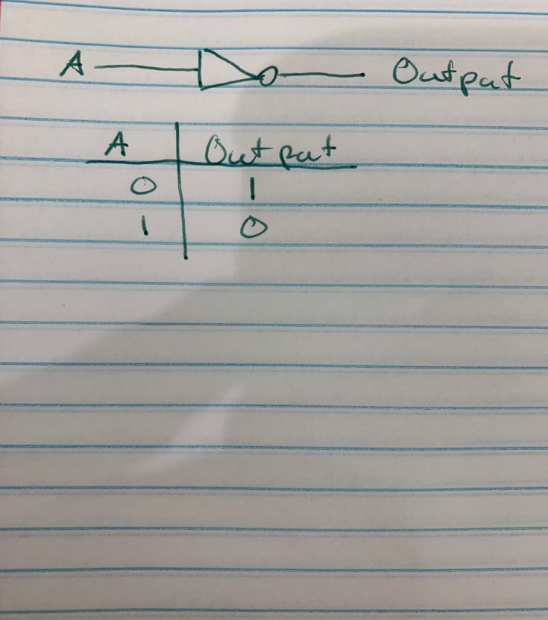

*Part C BJT Gates*

Brief description of Transistor gate experiment:

The objective of this experiment is to see how transistors can operate as certain logic gates. We will theoretically and physically construct these circuits in order to verify that these designs result in the desired logical outputs.



Complete the Truth Table for the above circuit.

|  |  |  |  |
| --- | --- | --- | --- |
| VA | VB | Vout |  |
| 0, 0V | 0, 0V | 1, 6V |  |
| 0, 0V | 1, 1V | 0, 6V |  |
| 1, 1V | 0, 0V | 0, 0V |  |
| 1, 1V | 1, 1V | 0, 0V |  |

Type of gate shown above: NOR

Schematic of LTspice version of the circuit.

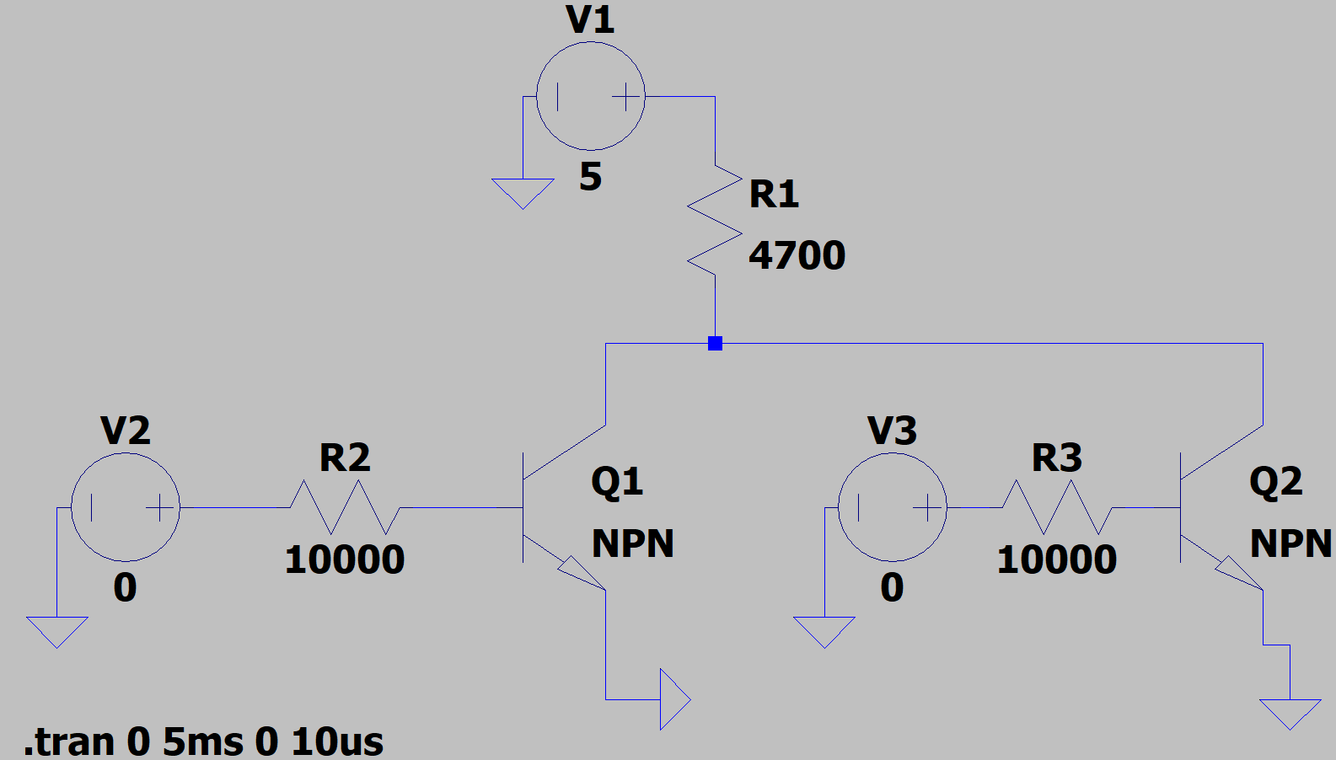

Plot of the input voltages and output voltages demonstrating the digital characteristics of the circuit. (LTspice

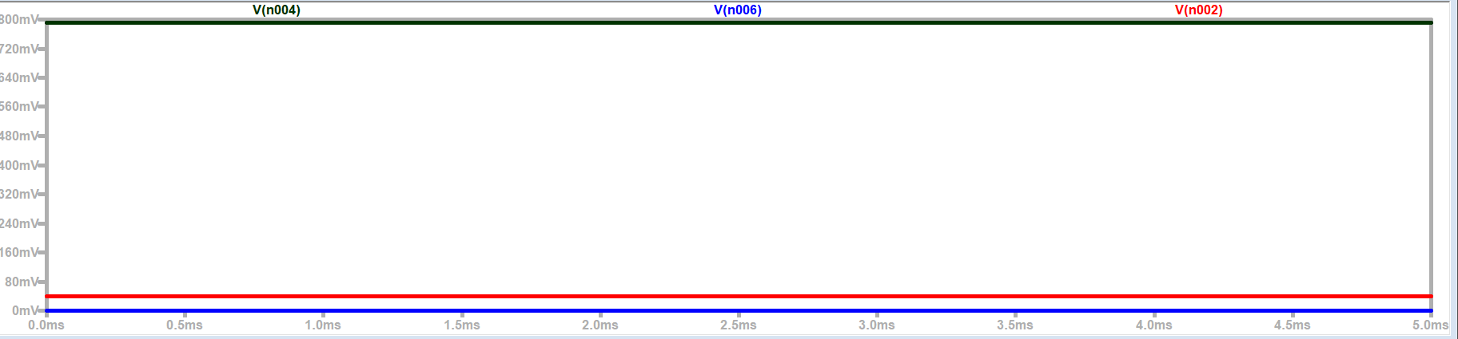

Black - Input 1 (5V)

Blue – Input 2 (5V)

Red – Output ~~(0V)

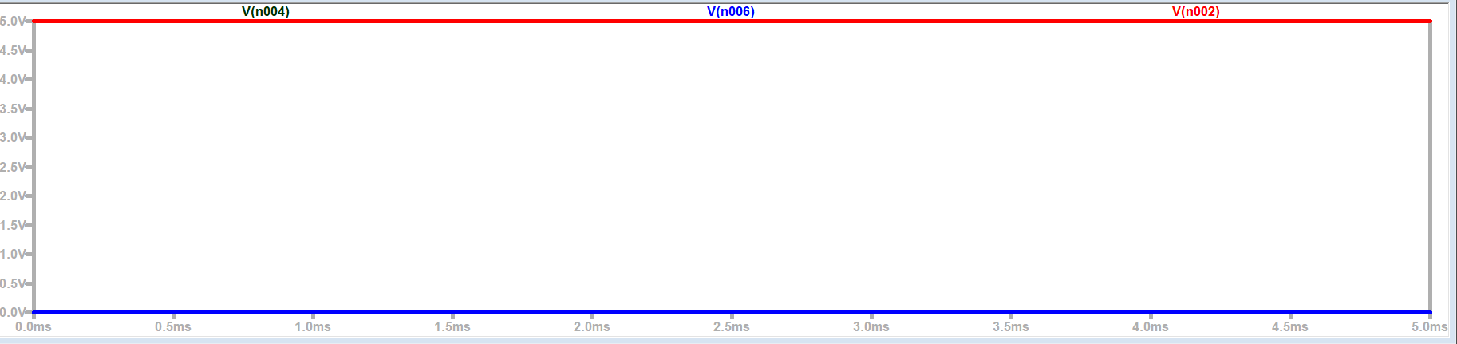

Black-Input 1 (0V)

Blue- Input 2 (0V)

Red- Output (5V)

Complete the Truth Table based on the simulation results.

|  |  |  |  |
| --- | --- | --- | --- |
| VA | VB | Vout |  |
| 0 | 0 | 1 |  |
| 0 | 1 | 0 |  |
| 1 | 0 | 0 |  |
| 1 | 1 | 0 |  |

Schematic of LTspice version of the circuit.



Plot of the input voltages and output voltages demonstrating the digital characteristics of the circuit. (Discovery Board)





Complete the Truth Table based on the experimental results.

|  |  |  |  |
| --- | --- | --- | --- |
| VA | VB | Vout |  |
| 0 | 0 | 1 |  |
| 0 | 1 | 0 |  |
| 1 | 0 | 0 |  |
| 1 | 1 | 0 |  |

**

Complete the Truth Table for the above circuit.

|  |  |  |  |
| --- | --- | --- | --- |
| VA | VB | Vout |  |
| 0, 0V | 0, 0V | 1, 6V |  |
| 0, 0V | 1, 1V | 1, 6V |  |
| 1, 1V | 0, 0V | 1, 6V |  |
| 1, 1V | 1, 1V | 0, 0V |  |

Type of gate shown above: NAND

Schematic of LTspice version of the circuit.

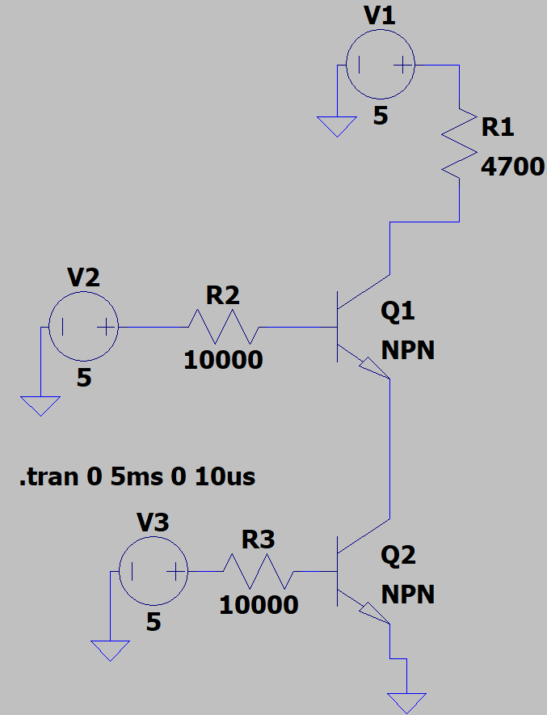

Plot of the input voltages and output voltages demonstrating the digital characteristics of the circuit. (LTspice)

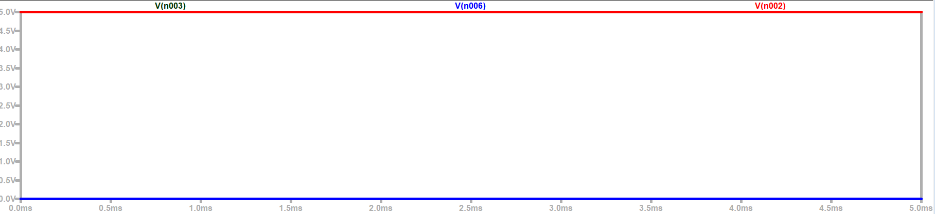

Black- Input 1 (0V)

Blue- Input 2 (0V)

Red- Output (5V)

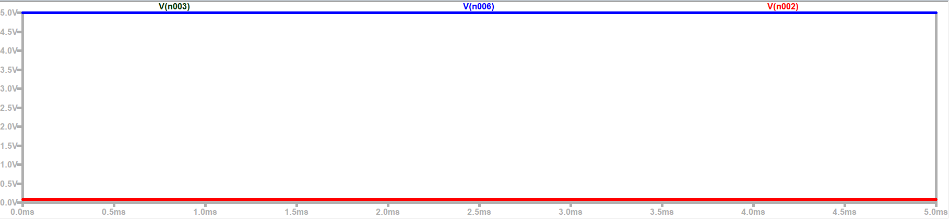

Black- Input 1 (5V)

Blue- Input 2 (5V)

Red- Output (0V)

Complete the Truth Table based on the simulation results.

|  |  |  |  |
| --- | --- | --- | --- |
| VA | VB | Vout |  |
| 0 | 0 | 1 |  |
| 0 | 1 | 1 |  |
| 1 | 0 | 1 |  |
| 1 | 1 | 0 |  |

Schematic of LTspice version of the circuit.



Plot of the input voltages and output voltages demonstrating the digital characteristics of the circuit. (Discovery Board)





Complete the Truth Table based on the experimental results.

|  |  |  |  |
| --- | --- | --- | --- |
| VA | VB | Vout |  |
| 0 | 0 | 1 |  |
| 0 | 1 | 1 |  |
| 1 | 0 | 1 |  |
| 1 | 1 | 0 |  |

*Part D NAND and NOR Logic*

Brief description of AND gate design:

The AND gate requires both inputs to be HIGH in order for the output to be HIGH. A NAND gate is a NOT AND. If A and B are input a NAND will give NOT(AB). Therefore in order to get AB you need to NOT(NOTAB)). Thus the schematic for a AND gate out of NAND gates is to NOT the NAND output as shown below.

Schematic of the AND gate.

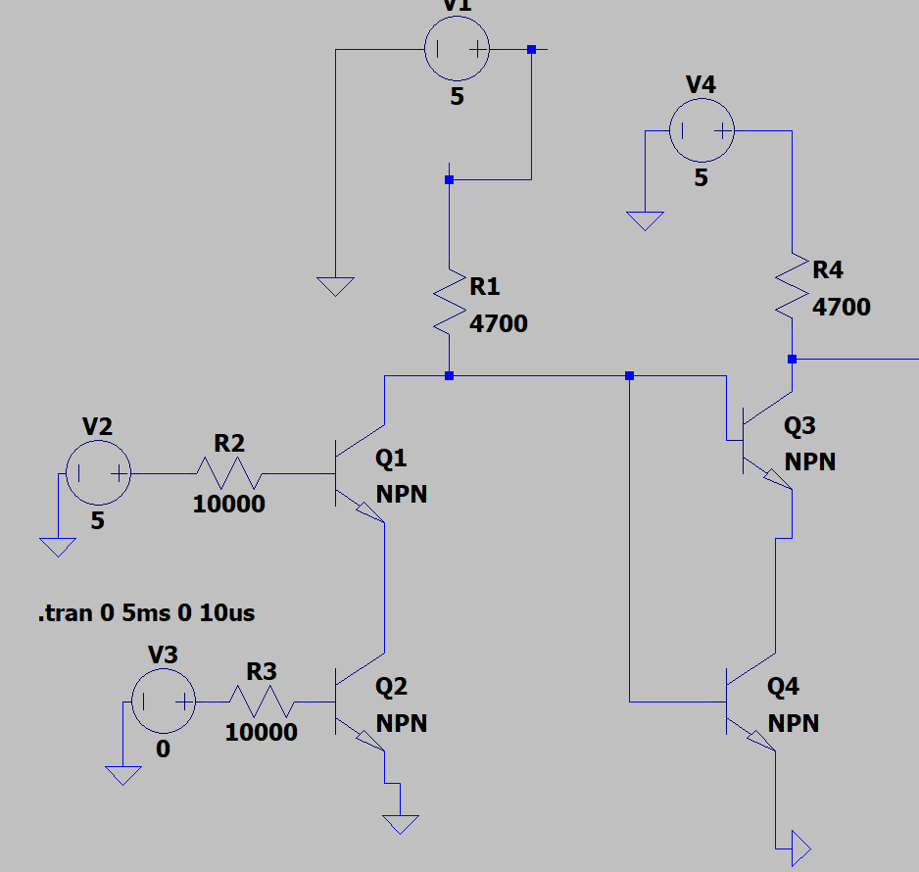

Simulation results verifying that the circuit configuration is an AND gate, with annotations. (LTspice)

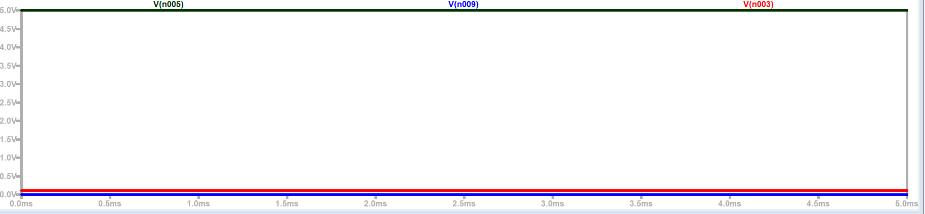

Black- Input 1 (5V)

Blue – Input 2 (0V)

Red- Output (0V)

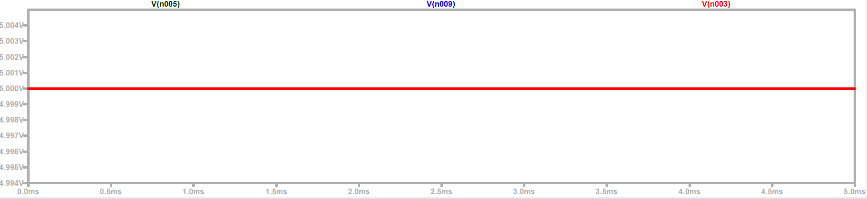

Black- Input 1 (5V)

Blue- Input 2 (5V)

Red- Output (0V)

*Part E Reflection*

What did you learn in this experiment?

Transistors are very important circuit components because they add logical complexity to circuits making operations more complex and dependent on user input. There are 6 fundamental logic gates used to make comparisons and output: NAND, NOR, OR, NOT, AND, XOR. These make up virtually every logical circuit. Configurations of these transistors make these circuits. Lastly, gates can be made using other gates using fundamental of logic/Boolean algebra.

How did the simulation and experimental results compare with expectations?

The simulation and experimental results matched almost exactly. Due to the real life implications, any “noise” within the logic circuit would be ignored due to activation voltages of transistors. In terms of binary High and Low values, the circuits were a picture perfect match. The logical combinations matched both in experimental and theoretical.